

Computer Vision

Section-1

Submitted to faculty: Professor Mehul Raval

Date of Submission: 30-03-2022

Student Details

Computer Vision-Super Image Resolution

| Roll No. | Name of the Student | Name of the Program |
| --- | --- | --- |
| AU1940109 | Jap Purohit | CV |
| AU1940034 | Varun Deliwala | CV |
| AU1940267 | Sahil Miskeen | CV |
| AU1940142 | Shail Patel | CV |

**Tasks performed this week:**

After the mid-sem report review, we have started to work on the feedback provided to us. Also, after getting the idea about super-image resolution and its works. We have started understanding the GAN (Generative adversarial networks) and the ways in which we can implement using the dataset which we have been using while understanding the bicubic and SRCNN models.

**Outcomes:**

Model which we understood from various research paper and articles:

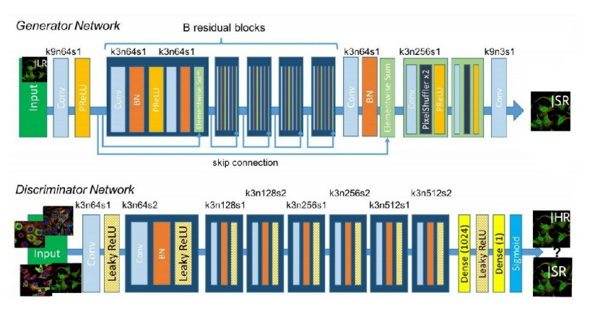

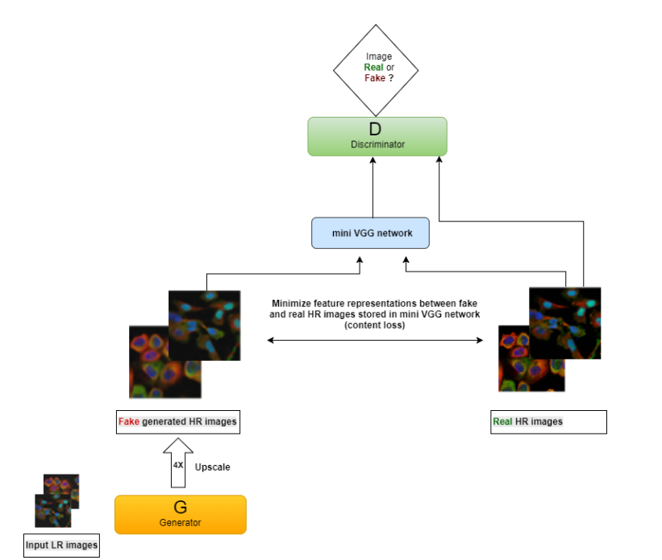

**Tasks to be performed next week:**

Try to understand the GAN better and start implementing the GAN model using the dataset which we used for SRCNN and Bicubic models so we can compare the results obtained from the GAN.

**References:**

1. <https://kth.diva-portal.org/smash/get/diva2:1216797/FULLTEXT01.pdf>
2. https://machinelearningmastery.com/tour-of-generative-adversarial-network-models/